ST. LUKE’S CATHOLIC HOSPITAL

PROCUREMENT
OF

NON-DRUG
CONSUMABLES

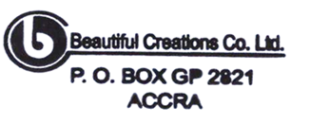

SQ NO.: CR/SLCH/GD/001/25

FEBRUARY, 2026

